From Evidence to Verdict: A Transaction-Centric,
Provenance-Preserving Multimodal Financial Auditing Architecture
Matisha Kansal  matishakansal.bt24cseai@pec.edu.in  Department of Computer Science and Engineering  Punjab Engineering College (Deemed to be University), Chandigarh, India | Ekamveer Singh  ekamveersingh.bt24cseai@pec.edu.in  Department of Computer Science and Engineering  Punjab Engineering College (Deemed to be University), Chandigarh, India | Pavni Gupta  pavnigupta.bt24cse@pec.edu.in  Department of Computer Science and Engineering  Punjab Engineering College (Deemed to be University), Chandigarh, India

Sahil Kumar  sahilkumar.bt24cse@pec.edu.in  Department of Computer Science and Engineering  Punjab Engineering College (Deemed to be  University), Chandigarh, India | Kanu Goel  kanugoel@pec.edu.in  Department of Computer Science and Engineering  Punjab Engineering College (Deemed to be  University), Chandigarh, India

Abstract—Financial auditing often requires an auditor to assemble evidence that is distributed across invoices, purchase orders, ledgers, bank records, spreadsheets, messages and scanned documents. This paper presents From Evidence to Verdict, a transaction-centric workflow that converts these sources into linked, reviewable audit evidence. The system combines multimodal ingestion, schema normalization, field-level provenance, deterministic reconciliation and hybrid retrieval-augmented generation (RAG). Email evidence can be collected from Gmail or Outlook through user-triggered IMAP synchronization; POS records can be submitted through a webhook, while barcode-based bill generation is provided as a demonstration path. A four-tier language-model cascade uses a logistic-regression router to decide whether an answer should be accepted or escalated. Parser evaluation covered 267 files: reported PDF field scores ranged from 98.63% to 100.0%, Excel/CSV extraction accuracy was 99.02%, and image OCR invoice-number extraction was 28.77%. Text/email payment-total extraction was 82.0%. The 20 audio inputs contained non-speech tones and were assessed for pipeline handling rather than speech transcription. In the 43-case held-out financial-audit test, the frozen router achieved 100.0% accuracy (43/43), with no false stops among the 39 cases terminated below L4. Always-L2 reached 90.7%. These results are preliminary and require replication on broader, independently sampled data.
Index Terms—financial auditing, transaction reconciliation, multimodal documents, evidence provenance, hybrid retrieval, retrieval-augmented generation, model routing.
I. INTRODUCTION
A single business transaction may be represented by several records created at different points in an operational process. An invoice describes what a supplier charged; a purchase order records what was authorized; a ledger entry records how the amount was posted; and a bank statement records whether money moved. Supporting details may arrive separately as email attachments, spreadsheets, scanned bills or voice notes. When these records are stored in different systems, an auditor must identify which items belong together, compare their values and preserve enough context for another reviewer to reproduce the finding.
Retrieval-augmented generation can locate relevant passages, but retrieval similarity alone does not establish that two records describe the same transaction or that their totals agree. A generated explanation is also not a substitute for recomputing amounts from source values. We therefore separate three operations: collecting and linking evidence, checking financial relationships with deterministic routines, and using language models to explain the resulting evidence. A mismatch is treated as a reason for review, not as proof of fraud; when necessary records are absent or contradictory, the system should report insufficient evidence.
From Evidence to Verdict is an implementation-oriented workflow for this task. Its contribution is the integration of heterogeneous evidence acquisition, source-aware transaction records, repeatable reconciliation, hybrid RAG and a routed explanation layer in one review process. The work makes four contributions: (i) a multimodal pipeline that ingests documents and connected records; (ii) a transaction-level representation that keeps extracted values linked to source locations; (iii) a division between deterministic financial checks and RAG-supported explanations; and (iv) an evaluation of parsing, identifier-based retrieval, record reconciliation and two stages of LLM-cascade testing. The system is intended to support auditors, not to make autonomous fraud or compliance decisions.
II. RELATED WORK
Retrieval-augmented generation conditions model responses on retrieved material rather than relying only on model parameters [1]. Recent financial systems extend this idea to documents containing narrative text, tables and figures. MultiFinRAG, for example, focuses on multimodal financial question answering over reports and presentations [2]. Cosentino et al. describe an auditable LLM-RAG pipeline for financial document intelligence, combining hybrid retrieval, grounded generation, structured validation and persistent processing artifacts [3]. These works establish that multimodal retrieval and audit-oriented RAG are active research directions; they are not claimed as new by this paper. The present system addresses a narrower operational problem: linking records that refer to the same purchase or payment and checking their numerical relationships across invoices, purchase orders, ledgers and bank records.
TAT-QA evaluates reasoning over financial tables and accompanying text [4], making it relevant to the cascade's earlier explanation test. FrugalGPT explores model cascades for reducing inference cost [5], while RouteLLM studies learned routing between models of different capability and cost [6]. The router in this work is a response-level logistic-regression component adapted to the audit workflow. Its decisions affect inference depth only; financial calculations remain outside the language-model cascade.
This workflow differs from document-level financial question answering: it follows a transaction across records created in separate systems and preserves the links and calculations behind each finding. Its contribution is this audit-oriented integration, not a claim that extraction, RAG, provenance or model routing is individually new.
III. SYSTEM DESIGN
The pipeline is organized around the movement of evidence from acquisition to a reviewable finding. Figure 1 summarizes the current implementation and distinguishes connected sources from demonstration paths. The stages share source identifiers and extraction metadata so that an answer can be traced to the records used to support it.
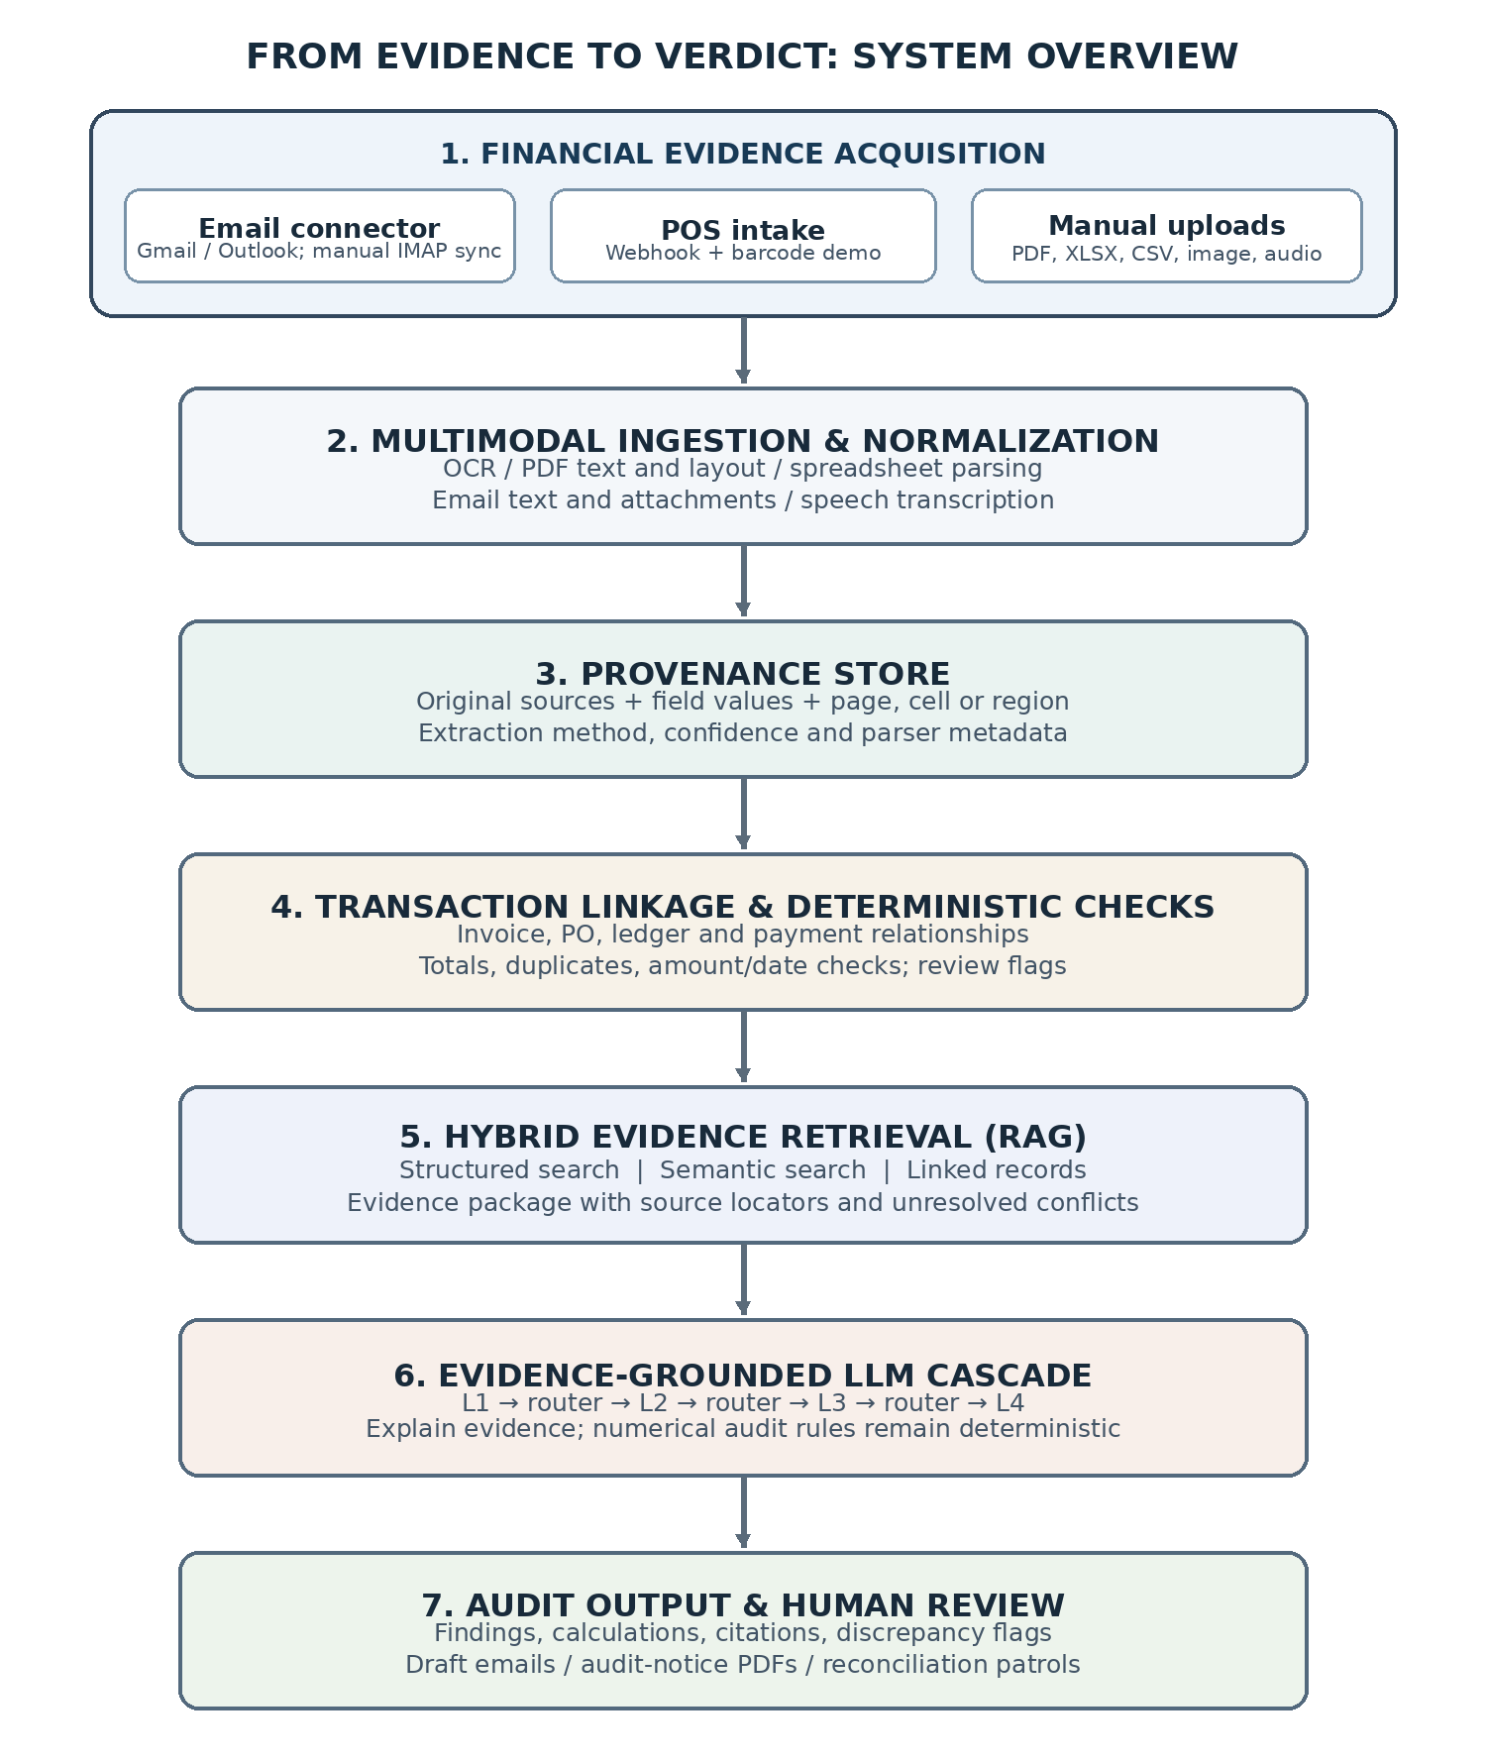
Fig. 1. Updated system architecture, including email synchronization, POS intake, hybrid RAG, the LLM cascade and auditor-facing actions.
A. Evidence Acquisition
The system accepts manual uploads and connected financial evidence. The email connector supports Gmail and Outlook through IMAP over SSL. Synchronization is initiated by the user through a Sync Email action; the current workflow is not a background or continuous mailbox monitor. Retrieved messages and supported attachments enter the same ingestion pipeline as uploaded files. For POS data, a webhook accepts structured bill payloads. A barcode-based demonstration can also resolve sample products from a local catalogue and generate item-level bills. No live third-party POS platform was connected in the reported evaluation, so the webhook is described as an integration interface rather than a validated vendor-specific connector.
Five content groups are processed: spreadsheets, scanned images, digital PDFs, plain-text financial messages and audio notes. Tesseract OCR is used for scanned material [7]; PyMuPDF extracts digital-PDF text and layout; Pandas reads spreadsheet and CSV data [8]; and Whisper converts speech to text [9]. The original source is retained alongside extracted content. For spreadsheets, row and column references are recorded; for page-based documents, page and region information is retained where available. OCR and speech confidence are treated as signals about extraction quality, not as proof that an extracted financial value is correct.
B. Evidence Normalization
Pydantic validation is applied to extracted fields such as dates, currencies, identifiers and required values before storage. Values that fail validation are recorded as exceptions instead of being silently repaired. PostgreSQL on Supabase stores frequently queried identifiers and totals in relational columns, while variable fields such as line items, raw parser output and modality metadata are held in JSONB. The data model contains business and party records, invoice headers, invoice items, payment details, source-file metadata and extraction records. Identifiers such as GSTIN may be used when present, but they are not the basis of the proposed audit workflow.
Each extracted fact is associated with a value, source-file identifier, locator and extraction metadata. A locator may identify a PDF page and region or a spreadsheet sheet, row and column. Parser method, confidence and validation status are retained where available. We represent an extracted fact as eⱼ = (vⱼ, fⱼ, lⱼ, mⱼ, qⱼ), where v is the extracted value, f is the source-file identifier, l is its page/cell/region locator, m is the extraction method and q is the confidence value when supplied by the parser. This makes a reported amount inspectable at the point where it was extracted, rather than leaving it only in a generated summary.
TABLE I. CORE TRANSACTION RECORDS
Record | Stored information
Business / party | Internal ID, name, address, currency and available party identifiers
Invoice header | Invoice ID, business ID, number, date, type, parties, totals and currency
Invoice item | Item ID, invoice ID, product code, description, quantity, unit price and taxable value
Payment | Date, amount, mode and payment reference
Source / extraction | File type, path or hash, page/region, parser method, confidence and field provenance

Frequently queried keys and totals are stored in relational columns; variable line items, payments, raw parser output and modality-specific metadata are retained in JSONB. Date and currency fields are normalized where the source permits it, and ledger directions are represented consistently so that receipts and outflows can be compared. Invalid values remain visible as parsing exceptions. The separation keeps common transaction queries efficient without discarding the original extraction context.
C. Transaction Reconciliation
Records are grouped using the identifiers and attributes available in the source material, including invoice numbers, vendor details, payment references, dates and amounts. Candidate links are not treated as confirmed solely because names or descriptions are similar. Uncertain or conflicting links are sent for review. Once records have been associated, SQL and Python routines compare invoice totals with purchase-order commitments, ledger entries and payment records. The checks also cover arithmetic consistency and duplicate records. These routines produce the numerical result and the records used to obtain it; an LLM is not asked to calculate or overrule the financial result.
D. Hybrid Evidence Retrieval
For an audit question, the retriever combines three routes. Structured retrieval queries indexed fields such as invoice identifiers, vendor names, dates, amounts and payment references. Semantic retrieval searches extracted text from PDFs, scans, messages and voice transcripts. Linked-record retrieval follows relationships among invoices, purchase orders, ledger entries and payments. The returned material is assembled into an evidence package containing normalized values, text excerpts, source locators, match information and unresolved conflicts. Structured queries are useful when a question supplies an exact identifier; semantic retrieval helps when the wording differs from the source; linked-record retrieval supplies the surrounding transaction context. These routes provide candidate evidence rather than a correctness verdict. The three routes are part of the proposed retrieval flow; the live retrieval evaluation reported here does not isolate the contribution of each route.
E. LLM Cascade
The explanation component uses four model tiers: L1 (gpt-oss:20b-cloud), L2 (gemma4:cloud), L3 (nemotron-3-super:cloud) and L4 (nemotron-3-ultra:cloud). A query is first sent to L1. A logistic-regression router then evaluates response-level features and decides whether to return the candidate response or escalate to a stronger tier. The 11-feature vector includes signals such as expressed confidence, hedging, numeric density, similarity to a previous tier's answer and answer-type flags for arithmetic or span extraction. The estimated probability for tier i is represented as:
pᵢ = σ(wᵢᵀxᵢ + bᵢ), stop if pᵢ ≥ τᵢ; otherwise escalate.
Here, σ is the logistic sigmoid, wᵢ and bᵢ are the trained parameters for tier i, and τᵢ is its stopping threshold. The router manages inference depth; deterministic routines remain responsible for arithmetic, schema checks and reconciliation. Retrieved evidence accompanies the query, and the resulting explanation must remain bounded by the evidence available to the audit pipeline.
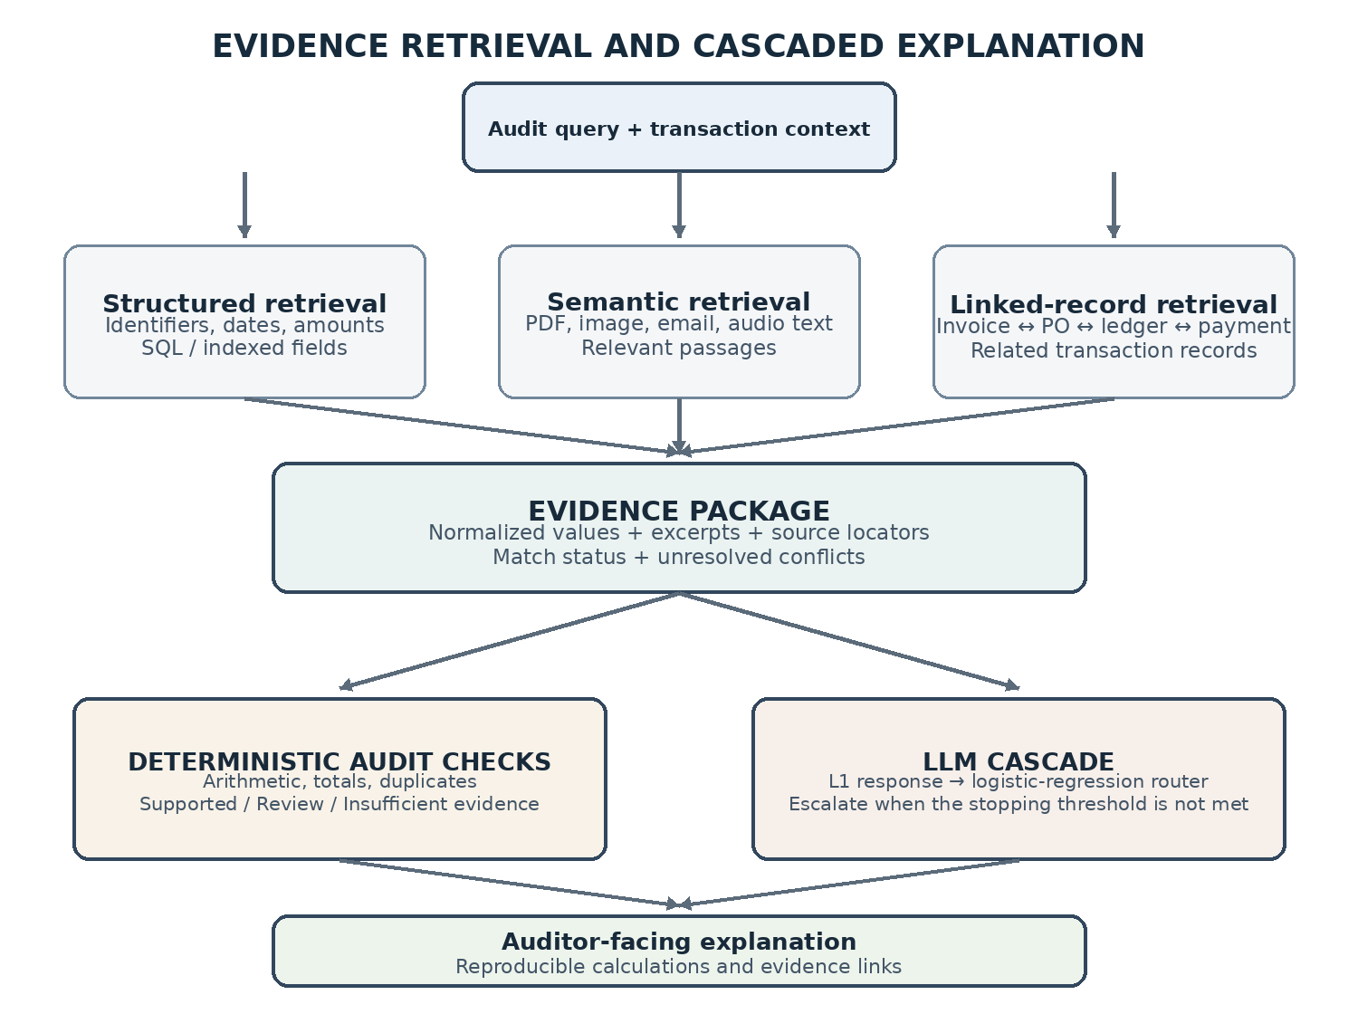
Fig. 2. Three retrieval paths form an evidence package; deterministic checks and the model cascade contribute separate parts of the audit output.
F. Audit Actions
The system also includes bounded audit actions: a vendor-dispute email can be prepared as a draft for human approval; an audit notice can be generated as a PDF; and a reconciliation patrol can flag duplicate invoices, unmatched payments or bank debits without corresponding invoice evidence. These actions assist follow-up work but do not make fraud decisions or send external communications autonomously. Their output quality has not been evaluated in a separate benchmark.
G. Traceability Contract
For a claim c, the audit record is represented as T(c) = (S_c, R_c, z_c). S_c contains the supporting source items and their locators; R_c identifies the deterministic rule or calculation when the claim depends on a computed check; and z_c records the review status. The status is one of SUPPORTED, REQUIRES_REVIEW or INSUFFICIENT_EVIDENCE. A reviewer can inspect the cited source values and repeat the stated calculation. If a required record is missing or two sources disagree, the system preserves the conflict and routes the finding for review. The cascade can explain the evidence package but cannot change the deterministic result.
IV. EVALUATION
A. Corpus Description
The parser benchmark covered 267 files: 73 digital PDFs, 50 text/email files, 51 Excel/CSV files, 73 invoice images and 20 audio files. The audio inputs contained non-speech tones; this subset therefore tests file handling and rejection of non-speech input, not speech-transcription accuracy. Parser results are reported by field where available. The modality-specific counts and field-level results are summarized in Table II.
B. Parser Evaluation
TABLE II. PARSER RESULTS BY MODALITY (267 FILES)
Modality | Accuracy
PDF | 98.63% to 100%
Text / email | 82.0%
Excel / CSV | 99.02%
Image OCR | 65.16 %
Audio | Pipeline handling 100%; Speech transcription not assessed

All 267 files passed through the parser without a reported crash. Results varied by field: PDF fields ranged from 98.63% to 100.0%; Excel/CSV reported 99.02% overall extraction accuracy and 3,472 line-item rows; text/email total extraction was 82.0%; and image OCR invoice-number extraction was 65.16%. The audio files were non-speech tones, so their 100.0% handling result does not measure speech recognition. Because field denominators and aggregate weighting were not supplied, Table II reports individual fields; these results describe the tested dataset only.
C. Retrieval Results
The live Supabase test covered 171 indexed chunks and ten invoice-identifier queries for one business. The top five results were checked for relevant evidence. Hit Rate@5 records whether at least one relevant item appears in the top five; Recall@5 records the fraction of labelled relevant evidence retrieved there; MRR summarizes the rank of the first relevant item. All ten queries returned the expected invoice identifier in the retrieved context, giving a Hit Rate@5 and Recall@5 of 100.0% and a grounding-support rate of 100.0% under the study's identifier-based definition. MRR was 77.5%, showing that the first relevant result was not always ranked first. This test does not establish answer correctness or performance on broader natural-language questions; direct structured lookup could also answer queries that already contain an invoice identifier.
D. Reconciliation Results
The reconciliation run examined 126 records grouped into 63 invoice groups. All 63 groups were marked consistent and no conflicting totals were found. Since the sample contained no verified or deliberately injected conflicts, this result shows that the reconciliation process completed on the available records; it does not measure discrepancy-detection precision or recall.
TABLE III. RETRIEVAL / RECONCILIATION METRICS
Evaluation | Result
Retrieval (Hit@5, Recall@5, MRR, grounding) | 100.0%, 100.0%, 77.5%, 100.0%
Reconciliation (records/groups; consistent/conflicting) | 126 / 63; 63 / 0

E. Cascade Evaluation
Two evaluations were conducted and are reported separately. Phase III used 50 TAT-QA questions [4] to compare the learned router cascade with an Always-L4 policy. The cascade answered 48 of 50 questions correctly (96.0%), compared with 100.0% for Always-L4. Mean latency fell from 16.29 s to 3.25 s (an 80.0% reduction in this setup), while mean generator tokens fell from 1,224.6 to 1,137.2 (7.1%). A false stop occurs when the router accepts a lower-tier answer that is incorrect; an unnecessary escalation occurs when it moves to a stronger tier even though the current answer is already correct. The observed rates were 4.0% (2/50) and 18.0% (9/50), respectively. All escalations in this sample stopped at L2.
Phase IV evaluated the integrated cascade on 120 financial-audit cases split into 51 training, 26 validation and 43 held-out test cases. The training split was used to fit the router; validation was used to select thresholds; and the frozen configuration was evaluated on the held-out cases. Models received the query and available evidence, not the reference answer. On the 43 test cases, the router stopped at L1 for 9 cases, L2 for 29, L3 for 1 and L4 for 4. It answered all 43 cases correctly (100.0%). None of the 39 cases terminated below L4 was an incorrect early stop (0/39, 0.0%). Table IV compares the frozen router with fixed-tier baselines.
TABLE IV. PHASE IV CASCADE AND FIXED-TIER RESULTS (N = 43)
Policy | Accuracy | False stops | Mean tokens
Frozen LR router | 100.0% (43/43) | 0/39 (0.0%) | 4,154
Always-L1 | 88.4% (38/43) | 5/43 (11.6%) | ~1,800
Always-L2 | 90.7% (39/43) | 4/43 (9.3%) | ~3,200
Always-L3 | 88.4% (38/43) | 5/43 (11.6%) | ~6,500
Always-L4 | 74.4% (32/43) | N/A | ~9,500

False-stop denominators differ: 0/39 for the router, 5/43 for Always-L1, 4/43 for Always-L2 and 5/43 for Always-L3; Always-L4 is N/A. Always-L2 was the strongest fixed-tier baseline (90.7%). The router used more tokens than L1/L2 but fewer than L3/L4. Validation results (96.2% accuracy; 0.0% false stops) informed calibration and are not held-out test results.
V. DISCUSSION
PDF and spreadsheet fields were strong, but image invoice-number (28.77%) and email payment-total (82.0%) extraction remained weaker. Missing annotation denominators limit generalisation; invoice-ID-only retrieval and conflict-free reconciliation also require broader testing.
Phase III reduced TAT-QA latency but returned two fewer correct answers than Always-L4 (2/50 false stops; 9/50 unnecessary escalations). In Phase IV, the router answered 43/43 held-out cases correctly, with 0/39 false stops among pre-L4 terminations. This result needs independent replication and used more tokens than Always-L1/L2. Connector and agentic tools have not been separately benchmarked.
VI. FUTURE WORK
Future tests should stratify PDFs and scans by layout, quality and table structure, document field denominators, and use genuine speech rather than non-speech tones. Reconciliation needs labelled mismatches, partial payments, duplicates and missing POs. RAG needs natural-language queries and route-wise evaluation. Larger held-out tests should assess cascade calibration, abstention, external POS and agentic actions under human approval.
VII. CONCLUSION
The system integrates multimodal financial evidence, source-linked records, deterministic reconciliation, hybrid RAG and routed explanations. Results across 267 files varied by field, with image OCR and informal payment totals remaining challenging. Broader independent tests are needed for retrieval, reconciliation and the cascade. The system supports auditor review, not autonomous audit or fraud detection.
Repository: github.com/MatishaKansal/Minor-Project
VIII. REFERENCES
[1] P. Lewis et al., “Retrieval-Augmented Generation for Knowledge-Intensive NLP Tasks,” in Advances in Neural Information Processing Systems, vol. 33, 2020, pp. 9459–9474.
[2] C. Gondhalekar, U. Patel, and F.-C. Yeh, “MultiFinRAG: An Optimized Multimodal Retrieval-Augmented Generation Framework for Financial Question Answering,” in Proc. IEEE Int. Conf. on Big Data, 2025, pp. 7163–7172, doi: 10.1109/BigData66926.2025.11401444.
[3] C. Cosentino, S. Squillace, and F. Marozzo, “An Auditable LLM-RAG Architecture for Financial Document Intelligence and Decision Support,” Future Internet, vol. 18, no. 6, Art. 284, 2026, doi: 10.3390/fi18060284.
[4] F. Zhu et al., “TAT-QA: A Question Answering Benchmark on a Hybrid of Tabular and Textual Content in Finance,” in Proc. 59th Annual Meeting of the Association for Computational Linguistics, 2021, pp. 3277–3287, doi: 10.18653/v1/2021.acl-long.254.
[5] L. Chen, M. Zaharia, and J. Zou, “FrugalGPT: How to Use Large Language Models While Reducing Cost and Improving Performance,” arXiv:2305.05176, 2023.
[6] I. Ong et al., “RouteLLM: Learning to Route LLMs from Preference Data,” in International Conference on Learning Representations, 2025.
[7] R. Smith, “An Overview of the Tesseract OCR Engine,” in Proc. 9th Int. Conf. on Document Analysis and Recognition, 2007, pp. 629–633.
[8] W. McKinney, “Data Structures for Statistical Computing in Python,” in Proc. 9th Python in Science Conference, 2010, pp. 56–61.
[9] A. Radford et al., “Robust Speech Recognition via Large-Scale Weak Supervision,” in Proc. 40th Int. Conf. on Machine Learning, 2023, pp. 28492–28518.

